Update
The next CRUD action we will tackle is the Update operation. Again let’s start in our cmd/routes.go file.
If you find yourself not knowing where to start when implementing any action, try adding a new route and let the errors guide you.
In our cmd/routes.go file, we need to add 2 new routes. We need a GET route that will take us to the edit form and another PATCH route that will actually update the record we are editing. GET and PATCH are HTTP verbs (methods) and aren’t specific to Go Fiber.
package main

import (
"github.com/divrhino/divrhino-trivia/handlers"
"github.com/gofiber/fiber/v2"
)

func setupRoutes(app *fiber.App) {
app.Get("/", handlers.ListFacts)
app.Get("/fact", handlers.NewFactView)
app.Post("/fact", handlers.CreateFact)
app.Get("/fact/:id", handlers.ShowFact)

// Display `Edit` form
app.Get("/fact/:id/edit", handlers.EditFact)
// Update fact
app.Patch("/fact/:id", handlers.UpdateFact)
}
Neither of these handlers exist yet, so we can head into our handlers package to create them.
Within the body of the EditFact handler, we create a new variable called fact to store the Fact we will be editing. Then we use the c.Params("id") method call to get the id value from the URL.
We query the database and retrieve the first record where the id matches. If we can’t find it, we render the NotFound handler. Otherwise, we will Render the view template and send the fact variable through to the frontend.
You may notice that this handler is very similar to the ShowFact handler, the main difference being we’re rendering different frontend views for each. If you’re feeling adventurous, you could consider DRYing out the code that is common between the two handlers.
func EditFact(c *fiber.Ctx) error {
fact := models.Fact{}
id := c.Params("id")

result := database.DB.Db.Where("id = ?", id).First(&fact)
if result.Error != nil {
return NotFound(c)
}

return c.Render("edit", fiber.Map{
"Title": "Edit Fact",
"Subtitle": "Edit your interesting fact",
"Fact": fact,
})
}
The next handler we’ll need to create is the UpdateFact handler which will persist the changes to the database. If we run into an error during the parsing step, we will send back a Service Unavailable status. If we get an error when trying to write these changes to the database, we will redirect to the edit template
func UpdateFact(c *fiber.Ctx) error {
fact := new(models.Fact)
id := c.Params("id")

// Parsing the request body
if err := c.BodyParser(fact); err != nil {
return c.Status(fiber.StatusServiceUnavailable).SendString(err.Error())
}

// Write updated values to the database
result := database.DB.Db.Model(&fact).Where("id = ?", id).Updates(fact)
if result.Error != nil {
return EditFact(c)
}

return ShowFact(c)
}
Now we need a frontend view so users can edit facts in the browser.
touch views/edit.html
Inside the edit.html file, we will create a simple form with the id attribute of form-update-fact. We will also store the current fact’s id column value inside a data attribute called data-factid. These id values might be confusing, but just be mindful that the first id is an HTML attribute that can be targeted by JavaScript and the fact’s id refers to the database column.
Then within the form body, we will add an input field for question, an input field for answer, and a submit button.
<div class="container">
<form id="form-update-fact" data-factid="{{ .Fact.ID }}">
<label for="question">
<span>Question</span>
<input type="text" name="question">
</label>

<label for="answer">
<span>Answer</span>
<input type="text" name="answer">
</label>

<input type="submit" value="Update">
</form>
</div>
We will also head into the show.html page and update the edit link so that its href value is pointing to our new edit route. We use {{ .Fact.ID }} to populate the id of the current fact we want to edit.
<div class="container flex">
{{if .Fact}}

<div class="content">
<p>{{ .Fact.Question }}</p>
<p>{{ .Fact.Answer }}</p>
</div>

<div class="actions">
<a href="/fact/{{ .Fact.ID }}/edit" class="btn-secondary">Edit</a>
<button class="btn-danger">Delete</button>
</div>
{{end}}
</div>
If we take a look at your Fact in the browser, it should be able to click on the Edit button. This will take you to the edit form
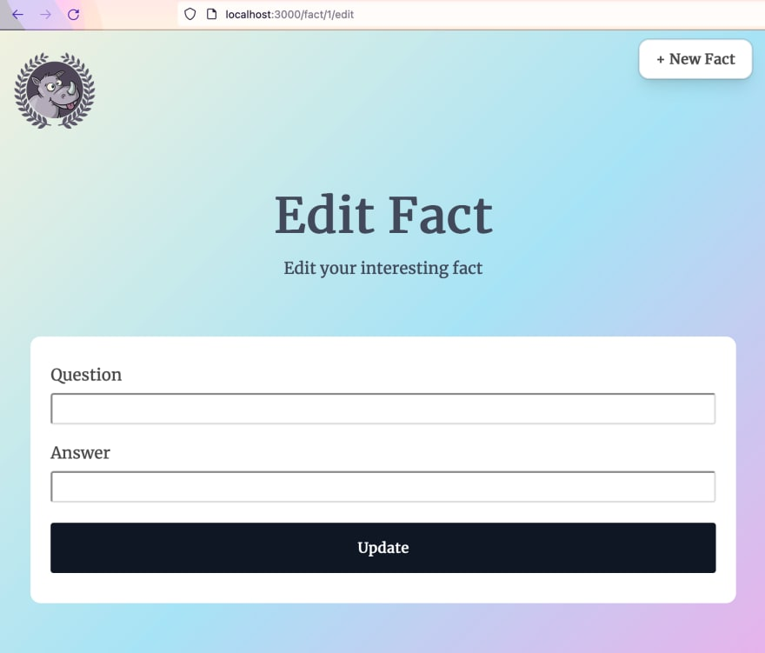
Currently, our form fields are empty. This isn’t ideal, because we should be able to see the values we want to change. We can remedy this by adding a value attribute to each of the fields. So the markup for our form should now look like this:
<div class="container">
<form id="form-update-fact" data-factid="{{ .Fact.ID }}">
<label for="question">
<span>Question</span>
<!-- Add value for Question field -->
<input type="text" name="question" value="{{ .Fact.Question }}">
</label>

<label for="answer">
<span>Answer</span>
<!-- Add value for Answer field -->
<input type="text" name="answer" value="{{ .Fact.Answer }}">
</label>

<input type="submit" value="Update">
</form>
</div>
views/index.html page because this was the only place in our app that was using JavaScript. Now, we’ve reached a point where we need JavaScript on other pages too, so we will need to import our script in a place that is accessible throughout the app. Let’s move our script tag from views/index.html into our main layout. So our views/layout/main.html file should now look like this:
<!DOCTYPE html>
<head>
<title>Div Rhino Trivia</title>
<meta name="viewport" content="width=device-width,initial-scale=1">
<link rel="stylesheet" href="/style/main.css">
</head>
<body>
...
</body>
</html>

<!-- import javascript file -->
<script src="/javascript/app.js"></script>
By default, all our static assets are cached so that the app is faster. This makes sense when our app is in production, because we do not want to keep fetching styles and scripts that have not changed. However, this can be annoying in development, because we need to make frequent changes to our CSS and JS while we’re building things.
We can work around the caching by appending a timestamp to the end of the asset urls. This hack should only be used, locally, though. We do not want to have this behaviour in production.
First, we can add an id attribute to our <link> and <script> tags so we can target them with JavaScript. Then we can add a little snippet that will append a timestamp to the end of each path. Notice that we also removed the ?v=1 query param from the end of the stylesheet path.
<!DOCTYPE html>
<head>
<title>Div Rhino Trivia</title>
<meta name="viewport" content="width=device-width,initial-scale=1">

<!-- Add id to stylesheet link tag -->
<link id="styles" rel="stylesheet" href="/style/main.css">
</head>
<body>
...
</body>
</html>

<!-- Add id to script tag -->
<script id="main" src="/javascript/app.js"></script>

<!-- For local development only: Snippet to append timestamps -->
<script>
const timeStamp = Date.now()
const stylesheetLink = document.querySelector("link#styles")
const appScriptLink = document.querySelector("script#main")
stylesheetLink.href += `?t=${timeStamp}`
appScriptLink.src += `?t=${timeStamp}`
</script>
We have now set up everything we need for the PATCH request. Inside the public/javascript/app.js file, we can paste in a snippet. This snippet uses the JavaScript fetch API to make a PATCH request to edit the current fact. JavaScript is outside the scope of this tutorial, so we will not step through every line of this snippet, but this is what is should look like:
// Get the editForm element and the current fact ID to edit
const editForm = document.querySelector('#form-update-fact')
const factToEdit = editForm && editForm.dataset.factid

// Add an event listener to listen for the form submit
editForm && editForm.addEventListener('submit', (event) => {
// Prevent the default behaviour of the form element
event.preventDefault()

// Convert form data into a JavaScript object
const formData = Object.fromEntries(new FormData(editForm));

return fetch(`/fact/${factToEdit}`, {
// Use the PATCH method
method: 'PATCH',
headers: {
'Content-Type': 'application/json'
},
// Convert the form's Object data into JSON
body: JSON.stringify(formData),
})
.then(() => document.location.href=`/fact/${factToEdit}`)// Redirect to show
})
Now we can try this out in the browser. If we visit http://localhost:3000/fact/1/edit and change the values, we can submit the edit form to update the current Fact.

